Patients and methods
Ethics committee:
- The study protocol was approved by the institutional ethical committee of Benha university hospitals.
- Informed patient written consent was obtained from every patient's parent before enrolment in the study.
Site of the study:
- Benha University Hospitals.
Type of the study:
- Prospective, comparative, double blind, randomized clinical trial.
Methods of randomization:
Patients were randomized into two equal groups, an online randomization program will be used to generate random number list (http:/www.randomizer.org). Patient randomization numbers were concealed in opaque envelops which opened by the study investigator.
Inclusion criteria:
- Age ranged between 3 – 12 years.
- ASA physical status I or II.
- Types of operation:
- Elective lower abdominal outpatient surgeries.
Groups allocation:
Patients were randomized into two equal groups:
- Group C: (control group): Depth of anesthesia guided by clinical parameters {standard practice [SP] group}.
- Group BIS: Depth of anesthesia guided by BIS (BIS group).
Exclusion criteria:
- Children with a history of premature delivery reported developmental delay.
- . Deafness.
- . Significant cardiovascular, respiratory, neurological disease.
- Children who were receiving medication known to affect the central nervous system.
Anesthetic management:
In the preoperative room:
The “stickers” put on the chest (the electrodes of electrocardiogram) and the head the electrodes for cerebral monitoring (BIS). Premedication was not offered to children in this trial.
At the operative room
On arrival at the operation room, standard monitoring devices, including continuous electrocardiogram, noninvasive blood pressure monitor, and pulse oximeter were applied to the patient. The BIS electrodes were placed on the forehead in group BIS,
Anesthesia was induced with sevoflurane via facemask: initially 8 vol % fraction inspired in combination with oxygen.
In the control group, the first anesthesiologist was responsible for the administration of sevoflurane and monitoring of the depth of anesthesia by using standard clinical signs with the goal of maintaining hemodynamic stability while avoiding patient movement and achieving a rapid recovery after surgery.
In the BIS group, a second anesthesiologist ensured proper functioning of the monitors during the operation and titrated the inspired sevoflurane concentration by 0.5% increments to maintain the BIS value within the range of 40-60, in the BIS group during the operation. If the patient moved during the operation, the inspired sevoflurane concentration was titrated by 0.5% increments depending on the patient’s clinical signs, and the events were recorded.
Five minutes before incision, patient received 1 mg/kg of fentanyl intravenously for analgesia.
At the end of surgery, defined as the time of final surgical suture, sevoflurane delivery was stopped and fresh gas flow was increased to 6 L/minute. The third investigator, who was also unaware of the grouping of the patient, was responsible for the assessment of the patient during the emergence and recovery period. The third anesthesiologist was the only observer in this study.
At the post-operative room:
On arrival at the post anesthesia care unit (PACU), the patients were accompanied by their parents. Behavior in the PACU was assessed by the trained observer using the pediatric anesthesia emergence delirium (PAED) score15 every 5 minutes after awakening for 30 minutes. The highest score during this period was used in the final PAED score. If the patient cried or was suffering from pain, meperidine1 mg/kg was given. If the agitation did not subside, meperidine 0.5 mg/kg and then midazolam 0.1 mg/kg were given. Readiness for PACU discharge was defined as a score of nine or more, with no zeros in any domains, on the Aldrete score16 and a room air O2 saturation 96%. Patients were then discharged directly from the PACU. At the time of discharge from the hospital, parents rated their satisfaction with their child’s anesthesia experience on a score from very good, good, acceptable, to bad experience. The patients were asked whether they could recall any event or dreaming during the intraoperative period at the follow-up interview by a nurse of the Anesthesia Department of the hospital.
The following measurements were recorded:
Parameters that were recorded :
- Demographic characteristics
Age, weight, sex and ASA physical status
- Type of operation
- Time of surgery
It is the time between skin incision and last surgical suture.
- Time of anesthesia
It is the time between starting the inhalation anesthesia (induction of anesthesia) and closure of it.
- Time for extubation
It is the time between closures of sevoflurane and removal of the tube after achieving the extubation criteria.
- Time to discharge to PACU
It is the time between removal of EET and discharge to PACU
- PACU time
It is the time between arrival of patient to PACU and discharge to internal ward by using modified Alderte score.

(Table 1): The modified Aldrete scoring system for determining when patients are ready for discharge from the post anesthesia care unit.
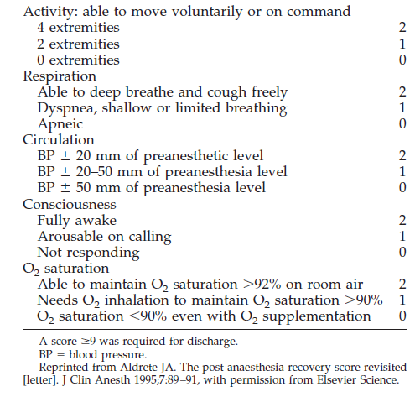

Pediatric anesthesia emergence delirium (PAED):
On arrival at the post anesthesia care unit (PACU), Emergence behavior was assessed by the trained observer using the pediatric anesthesia emergence delirium (PAED) score every 5 minutes after awakening for 30 minutes. The highest score during this period will be used in the final PAED score. Readiness for PACU discharge is defined as a score of nine or more, with no zeros in any domains
- Hospital stay time
It is the period of staying the patient in the internal round up to discharge from hospital.
- Hemodynamic parameters:
Heart rate (HR), mean arterial blood pressure (MAP), respiratory rate (RR) and oxygen saturation (SpO2).
- End tidal sevoflurane conc.
- Data Management and Statistical Analysis :
- Analysis of data was done by using SPSS version 16.
- Quantitative data was presented as mean ± Standard deviation.
- Qualitative data was presented as numbers and percentages.
- Quantitative data was analyzed by using unpaired student t-test.
- Qualitative data was analyzed by using Chi-square test and Fisher exact test.
- Quantitative data of repeated measures in the same group was analyzed by using repeated measures ANOVA test and the significant measures were detected by post-hoc analysis.
- P – Value < 0.05 was considered statistically significant.
- P – Value < 0.01 was considered statistically highly significant.

